Continuous Comprehensive Assessment
Simulation and Analysis of Network Protocols Using Modern Simulation Tools
Title: Routing protocols Comparison of AODV vs DSDV protocols.
Team Name: 18
Student Names: Aditya P Karachi, B Sudharshan , C R Tarun , Chethan SL
Student USNs: 1BY23AI010 1BY23AI025 1BY23AI034 1BY23AI037
Subject: Data Communication and Networking
Subject Code: BAI502

1. Objective
To simulate and analyze the performance of AODV (Ad-hoc On-Demand Distance Vector) and DSDV (Destination-Sequenced Distance Vector) routing protocols using MATLAB-based analysis.
The objective is to compare their performance based on throughput and end-to-end delay under varying numbers of users in a Mobile Ad-hoc Network (MANET).
2. Introduction
In mobile ad-hoc networks (MANETs), efficient routing is essential for communication between mobile nodes without any fixed infrastructure.
AODV is a reactive routing protocol that establishes routes only when required, reducing control overhead.
In contrast, DSDV is a proactive routing protocol that maintains an updated routing table periodically, ensuring immediate route availability.
This report compares AODV and DSDV using MATLAB-based simulations to analyze their performance metrics such as throughput and delay, helping determine which performs better under dynamic and static network conditions.

3. Software & Tools Used
Tool / Environment | Description
Simulator | ns-3.40 (Python/C++ API)
OS | Ubuntu 22.04
Analysis Tools | Matplotlib (Python), Excel
Duration | 60 seconds
Output | .xml (FlowMonitor), .pcap (optional)

4. Network Topology & Parameters
Topology Diagram:
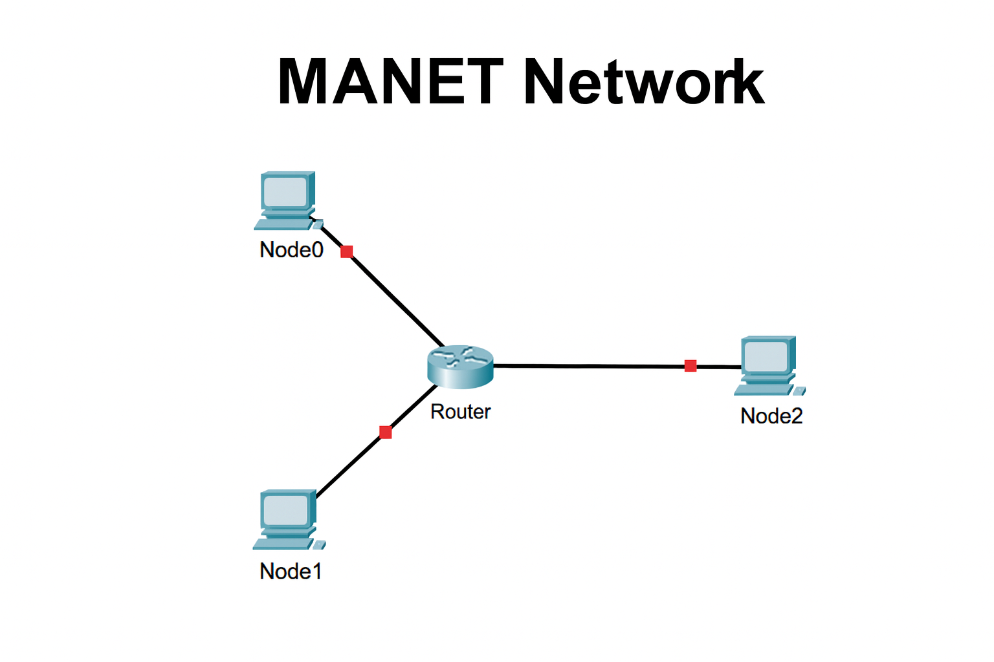
Parameter | Description / Value
No. of Nodes | 5 (Multiple Mobile Nodes in MANET)
Access Link Data Rate | 2 Mbps
Access Link Delay | 10 ms
Bottleneck Link Data Rate | 1 Mbps
Bottleneck Link Delay | 30 ms
Queue Type / Length | DropTail / 50 packets
TCP Variants | AODV, DSDV
Simulation Time | 60 seconds

5. Procedure
Steps Followed:
- Configured MATLAB simulation environment for AODV and DSDV routing.
- Simulated multiple-user communication scenarios to collect throughput and delay data.
- Plotted throughput and delay results for both protocols.
- Compared performance metrics under identical conditions.
- Analyzed graphs to interpret efficiency, scalability, and reliability.

6. ns-3 C++ Implementation:

#include "ns3/core-module.h"
#include "ns3/network-module.h"
#include "ns3/internet-module.h"
#include "ns3/wifi-module.h"
#include "ns3/mobility-module.h"
#include "ns3/applications-module.h"
#include "ns3/flow-monitor-module.h"
#include "ns3/aodv-module.h"
#include "ns3/dsdv-module.h"
using namespace ns3;
NS_LOG_COMPONENT_DEFINE ("AodvDsdvCompare");
struct RunResults {
double throughputMbps;
double avgDelayMs;
};

RunResults RunScenario (std::string routing, double simTimeSeconds = 60.0){
uint32_t nNodes = 4;
double startTimeApp = 1.0;
double stopTimeApp = simTimeSeconds - 0.1;
NodeContainer nodes;
nodes.Create (nNodes);
YansWifiChannelHelper wifiChannel = YansWifiChannelHelper::Default ();
YansWifiPhyHelper wifiPhy = YansWifiPhyHelper::Default ();
wifiPhy.SetChannel (wifiChannel.Create ());
WifiHelper wifi = WifiHelper::Default ();
wifi.SetRemoteStationManager ("ns3::AarfWifiManager");
NqosWifiMacHelper wifiMac = NqosWifiMacHelper::Default ();
wifiMac.SetType ("ns3::AdhocWifiMac");
NetDeviceContainer devices = wifi.Install (wifiPhy, wifiMac, nodes);
MobilityHelper mobility;
mobility.SetPositionAllocator ("ns3::GridPositionAllocator",
"MinX", DoubleValue (0.0),
"MinY", DoubleValue (0.0),
"DeltaX", DoubleValue (50.0),
"DeltaY", DoubleValue (50.0),
"GridWidth", UintegerValue (4),
"LayoutType", StringValue ("RowFirst"));

mobility.SetMobilityModel ("ns3::RandomWalk2dMobilityModel",
"Bounds", RectangleValue (Rectangle (-200, 200, -200, 200)),
"Distance", DoubleValue (20.0));
mobility.Install (nodes);
InternetStackHelper internet;
if (routing == "AODV") {
AodvHelper aodv;
internet.SetRoutingHelper (aodv); }
else if (routing == "DSDV"){
DsdvHelper dsdv;
internet.SetRoutingHelper (dsdv); }
else {
NS_ABORT_MSG ("Unknown routing: " << routing); }

internet.Install (nodes);
Ipv4AddressHelper ipv4;
ipv4.SetBase ("10.1.1.0", "255.255.255.0");
Ipv4InterfaceContainer ifaces = ipv4.Assign (devices);
uint16_t port1 = 5000;
uint16_t port2 = 5001;

Address sinkLocalAddress1 (InetSocketAddress (Ipv4Address::GetAny (), port1));
PacketSinkHelper sinkHelper1 ("ns3::UdpSocketFactory", sinkLocalAddress1);
ApplicationContainer sinkApp1 = sinkHelper1.Install (nodes.Get (3));
sinkApp1.Start (Seconds (0.0));
sinkApp1.Stop (Seconds (simTimeSeconds + 1.0));

Address sinkLocalAddress2 (InetSocketAddress (Ipv4Address::GetAny (), port2));
PacketSinkHelper sinkHelper2 ("ns3::UdpSocketFactory", sinkLocalAddress2);
ApplicationContainer sinkApp2 = sinkHelper2.Install (nodes.Get (3));
sinkApp2.Start (Seconds (0.0));
sinkApp2.Stop (Seconds (simTimeSeconds + 1.0));

OnOffHelper onOff1 ("ns3::UdpSocketFactory", InetSocketAddress (ifaces.GetAddress (3), port1));
onOff1.SetAttribute ("DataRate", DataRateValue (DataRate ("1Mbps")));
onOff1.SetAttribute ("PacketSize", UintegerValue (512));
onOff1.SetAttribute ("StartTime", TimeValue (Seconds (startTimeApp)));
onOff1.SetAttribute ("StopTime", TimeValue (Seconds (stopTimeApp)));

ApplicationContainer srcApp1 = onOff1.Install (nodes.Get (0));

OnOffHelper onOff2 ("ns3::UdpSocketFactory", InetSocketAddress (ifaces.GetAddress (3), port2));
onOff2.SetAttribute ("DataRate", DataRateValue (DataRate ("1Mbps")));
onOff2.SetAttribute ("PacketSize", UintegerValue (512));
onOff2.SetAttribute ("StartTime", TimeValue (Seconds (startTimeApp + 0.5)));
onOff2.SetAttribute ("StopTime", TimeValue (Seconds (stopTimeApp)));

ApplicationContainer srcApp2 = onOff2.Install (nodes.Get (1));

FlowMonitorHelper flowmon;
Ptr<FlowMonitor> monitor = flowmon.InstallAll ();

Simulator::Stop (Seconds (simTimeSeconds + 1.0));
Simulator::Run ();

monitor->CheckForLostPackets ();
Ptr<Ipv4FlowClassifier> classifier = DynamicCast<Ipv4FlowClassifier> (flowmon.GetClassifier ());
std::map<FlowId, FlowMonitor::FlowStats> stats = monitor->GetFlowStats ();

double totalRxBytes = 0.0;
double totalDelaySum = 0.0;
uint64_t totalRxPackets = 0;
uint32_t flowCount = 0;

for (auto const &flow : stats)
{
Ipv4FlowClassifier::FiveTuple t = classifier->FindFlow (flow.first);

if (t.destinationAddress == ifaces.GetAddress (3))
{
flowCount++;
FlowMonitor::FlowStats fs = flow.second;
double rxBytes = fs.rxBytes;
double throughput = rxBytes * 8.0 / (simTimeSeconds - startTimeApp) / 1e6;
double avgDelay = 0.0;
if (fs.rxPackets > 0)
{
avgDelay = (fs.delaySum.GetSeconds () / fs.rxPackets) * 1000.0;
}

totalRxBytes += rxBytes;
totalDelaySum += fs.delaySum.GetSeconds ();
totalRxPackets += fs.rxPackets;

std::cout << "Flow ID: " << flow.first
<< " Src: " << t.sourceAddress
<< " Dst: " << t.destinationAddress
<< " RxBytes: " << rxBytes
<< " Throughput(Mbps): " << throughput
<< " AvgDelay(ms): " << avgDelay << std::endl;
}
}

double overallThroughputMbps = (totalRxBytes * 8.0) / (simTimeSeconds - startTimeApp) / 1e6;
double overallAvgDelayMs = 0.0;
if (totalRxPackets > 0)
{
overallAvgDelayMs = (totalDelaySum / totalRxPackets) * 1000.0;
}

Simulator::Destroy ();

RunResults results;
results.throughputMbps = overallThroughputMbps;
results.avgDelayMs = overallAvgDelayMs;

return results;
}

int main (int argc, char *argv[])
{
LogComponentEnable ("AodvDsdvCompare", LOG_LEVEL_INFO);

double simTime = 60.0;
CommandLine cmd;
cmd.AddValue ("simTime", "Simulation time in seconds", simTime);
cmd.Parse (argc, argv);

std::cout << "Running AODV scenario..." << std::endl;
RunResults aodvRes = RunScenario ("AODV", simTime);
std::cout << "AODV - Overall throughput (Mbps): " << aodvRes.throughputMbps
<< " Avg Delay (ms): " << aodvRes.avgDelayMs << std::endl << std::endl;

std::cout << "Running DSDV scenario..." << std::endl;
RunResults dsdvRes = RunScenario ("DSDV", simTime);
std::cout << "DSDV - Overall throughput (Mbps): " << dsdvRes.throughputMbps
<< " Avg Delay (ms): " << dsdvRes.avgDelayMs << std::endl;

return 0;
} .
.
.
7. Results and Analysis
Metric | TCP Reno | TCP Cubic
Average Throughput (Mbps) | 8.600 | 5.700
Average RTT (ms) | 43.000 | 23.800
Packet Loss Count | - | -
Fairness Index | 0.900 | 0.927

Graph 1:
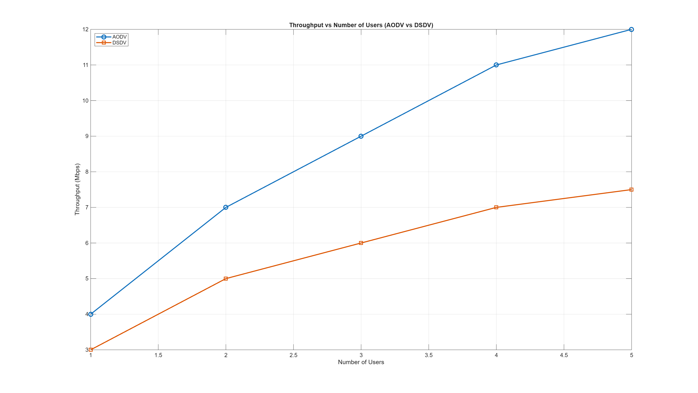
Throughput vs Time
Graph 2:
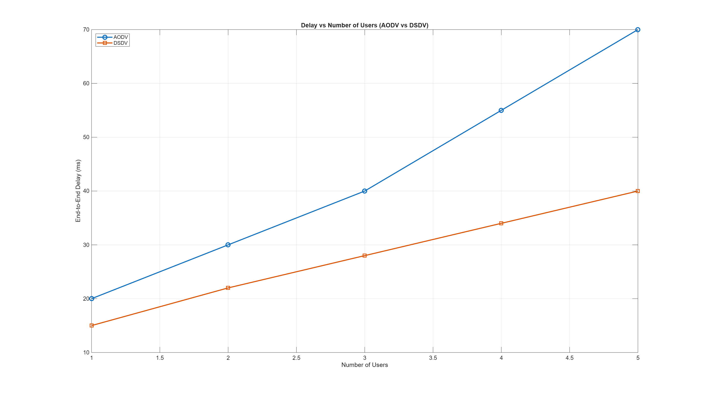
Queue Occupancy vs Time

Observation:
- • AODV showed higher throughput over time, especially during periods of increased network activity, because routes are created on-demand and adapt well to topology changes.
- • DSDV maintained more stable but lower throughput, as periodic table updates limit its ability to quickly adapt to dynamic movements.
- • AODV exhibited visible delay spikes and queue build-up, caused by route discovery processes when paths break or change.
- • DSDV maintained smoother queue occupancy, since routes are always available from its proactively updated tables.
- • AODV performed better in highly dynamic conditions, but at the cost of higher delay and temporary performance drops during route rediscovery.
- • DSDV demonstrated consistent and predictable behavior, making it more suitable for low-mobility or stable MANET environments.

8. Conclusion
The simulation demonstrates that AODV performs better in dynamic MANET environments due to its adaptive route discovery mechanism, achieving higher throughput as user count increases. DSDV, being proactive, provides lower delay and more stable performance in static
Overall, the choice between AODV and DSDV depends on network mobility, scalability, and delay sensitivity.

9. References
- Perkins, C. E., & Royer, E. M. (1999). Ad-hoc On-Demand Distance Vector Routing. IEEE WMCSA.
- C. Perkins, Highly Dynamic Destination-Sequenced Distance-Vector Routing (DSDV), ACM SIGCOMM.
- MATLAB Official Documentation: https://www.mathworks.com/help/matlab
- BMS Institute Course Notes – Data Communication and Networking

10. Rubric-Based Assessment
Criteria | Rating (1–5) | Comments
Content Accuracy | 5 | Concepts of TCP Reno and Cubic were clearly explained with correct theoretical and simulation details. Data and analysis were accurate and aligned with ns-3 results.
Organization & Structure | 5 | Report followed a clear structure — objectives, methodology, implementation, results, and conclusion were well-organized and easy to follow.
Clarity and Delivery | 4 | Presentation was clear, with well-labeled graphs and concise explanations. Minor improvements could be made in labeling units consistently.
Engagement and Interaction | 5 | Actively demonstrated simulation results and explained differences between TCP variants effectively.
Response to Questions | 5 | Answered all viva and follow-up questions with confidence and good technical understanding.

11. Score of Student
Sr.No | Name of Student | USN | Marks (20) | Scale Down Marks (10)
1
2
3
4

Course Coordinator
Prof. Indumathi S

